
CANATURE CABINET
WATER SOFTENER CS16H
- 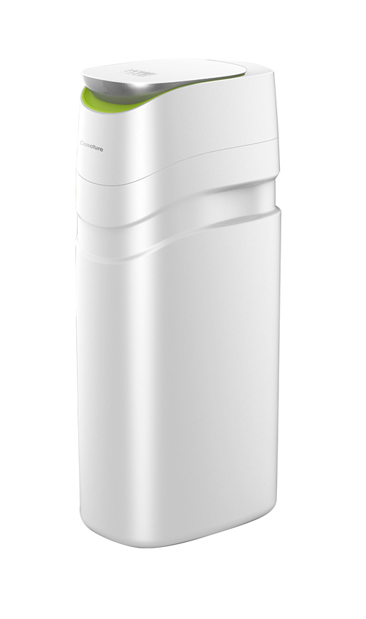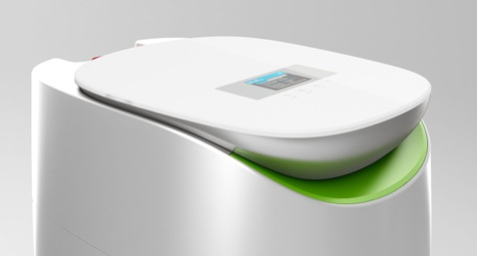
Dimensions: H1004mm x W325mm x D480mm

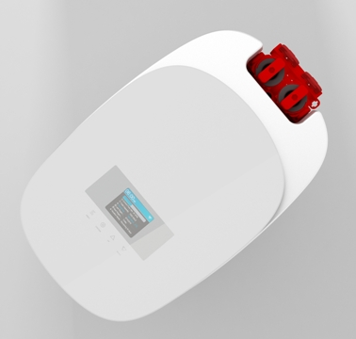

CANATURE CABINET WATER SOFTENER Model CS16H

Features

1. Exclusive NSF Certified electronic control valve with reliable piston, seal and spacer technology.
2. User-friendly large colour LCD display, improved interface design.
3. Touch keys design on a high strength tempered glass, high end and easy to operate.
4. Time saving quick connect fittings on bypass, drain and brine line for easy installation
5. Space saving bypass with integrated turbine meter, include bypass tool, for easy operation..
7. Soft Water Brine Tank Refill keeps tank & injectors clean.
8. Information display rotates key info; last regeneration date, volume remaining & system capacity.
9. Self-charging battery back-up for 48 hours.
10. Integrated By-Pass for extensive watering without softened water – more economical.
11. Holiday Mode: Flushes water after 7 days of non-use to refresh and prevent bacteria growth.
12. Option to detect the salt volume in the cabinet to remind you to add salt

Salt storage: 64Kg = 3 x 20Kg bags
Callfree 0800 177 000

